**Assessment of seasonal patterns in crop rotation with Google Earth Engine**

Submitted by

**Mustafa Kamal Shahadat**

Student ID: 2965623

**• Define the study area (use the shapefile provided to define the study area of Castilla La-Mancha)**

For spain ‘castilla La-Mancha’ study area is defined

And for Bangladesh study area ‘bd’ is defined.

**• Add the time series: The script provided uses MODIS data but the student can adapt the script to Landsat data if the agricultural plots are very small**

Time series data (Modis) has been added in both GEE File.

**• Estimate the spectral metric used as ecological indicator: The script provided estimates the vegetation index NDVI but the student can consider other metric based on their knowledge of the study area.**

NDVI has been calculated in both cases.

**• Estimate the trend and evaluate if it is necessary to detrend the time series (add a map of the trend in the report indicating maximum, minimum and mean values)**

There are seasonality patterns seen In the graph, so it is necessary to detrend the time series.

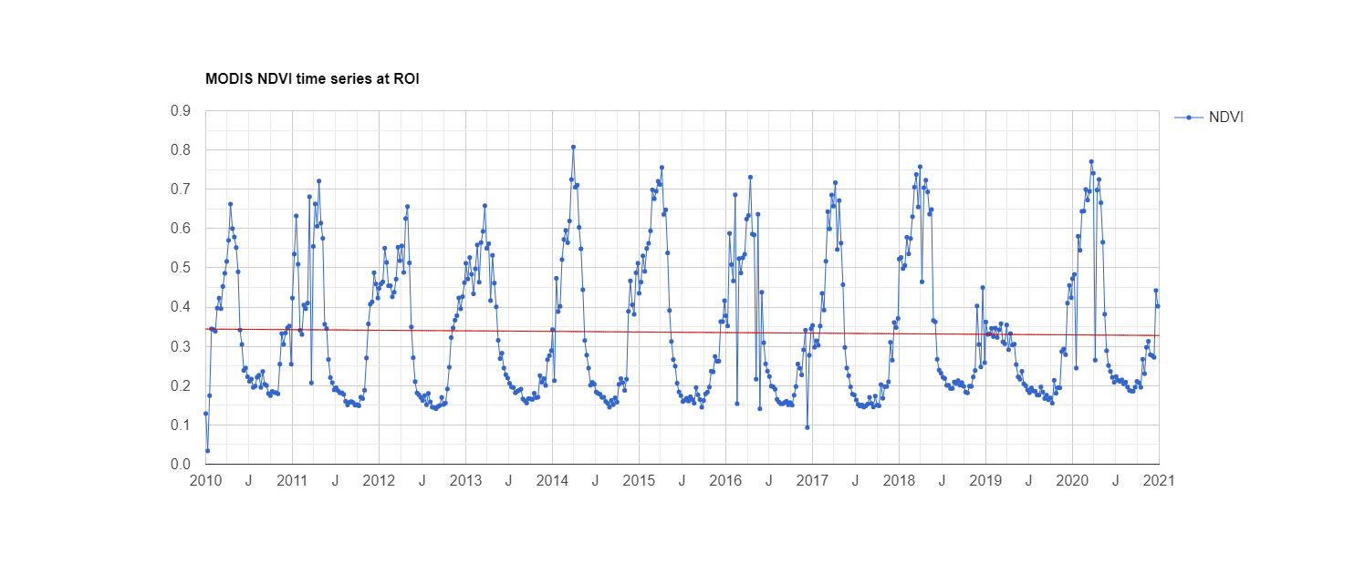

Fig: NDVI Trend chart of Castalia_la_Mancha (Maximum: 0.851, minimum: -0.008 and mean: 0.340)

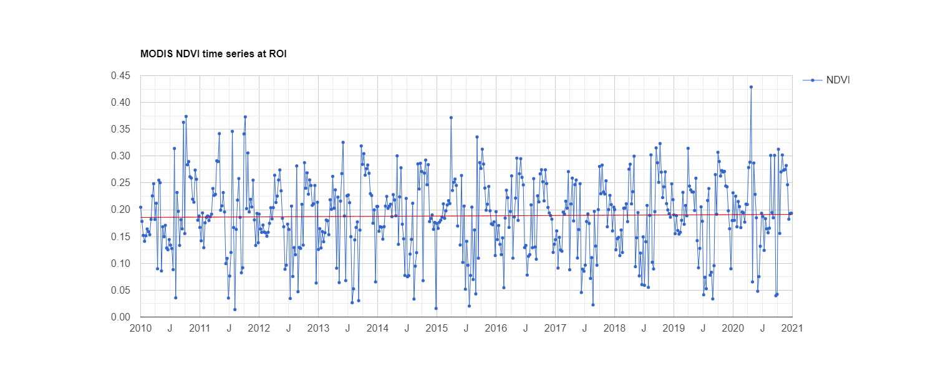

Fig: NDVI Trend chart of Bangladesh (Maximum: 0.429, minimum: 0.014 and mean: 0.188)

* **Define harmonic Function**

Harmonic function, also termed spectral analysis or Fourier analysis, decomposes a time dependent periodic phenomenon into a series of sinusoidal functions, each defined by unique amplitude and phase values. Each harmonic term accounts for a proportion of the variance in the original time series.

From the trigonometric identity a harmonic function is written as:

α sen (ωt+δ) = A sen(ωt)+ B cos(ωt)

Where the amplitude α and the phase δ verify:

α 2 = A2 + B2

δ = arctan (-B/A)

Yt = µ + A sen(ωt)+ B cos(ωt) + e

• Estimate the amplitude of the phenological cycle (add a map of the amplitude in the  
report indicating maximum, minimum and mean values)

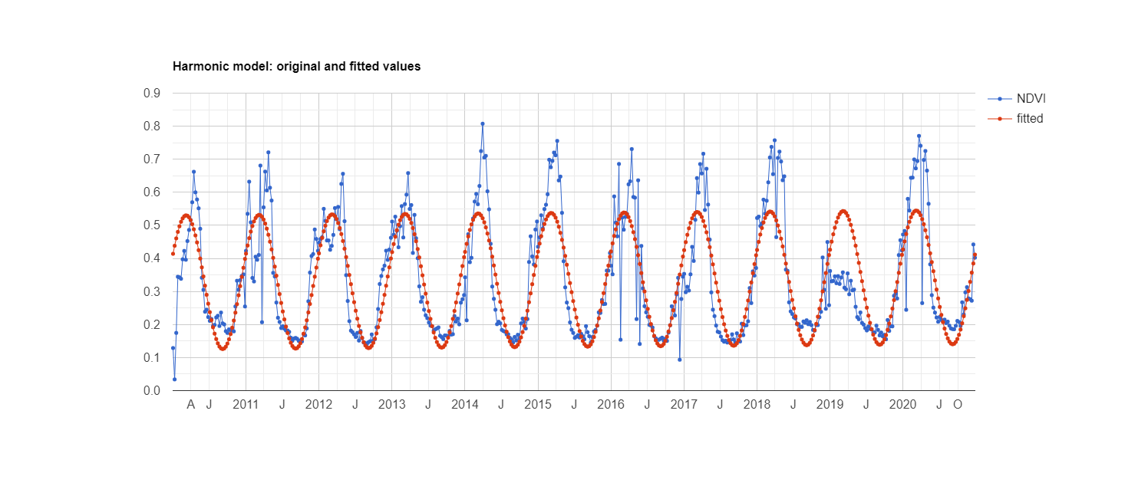

Fig: Harmonic model for Castallia_la_mancha. Vertical green line shows the amplitude and horizontal line shows the phase of harmonic line.

For Castallia_la_mancha, Spain: Maximum = 0.545, Minimum = 0.126 and mean = 0.336

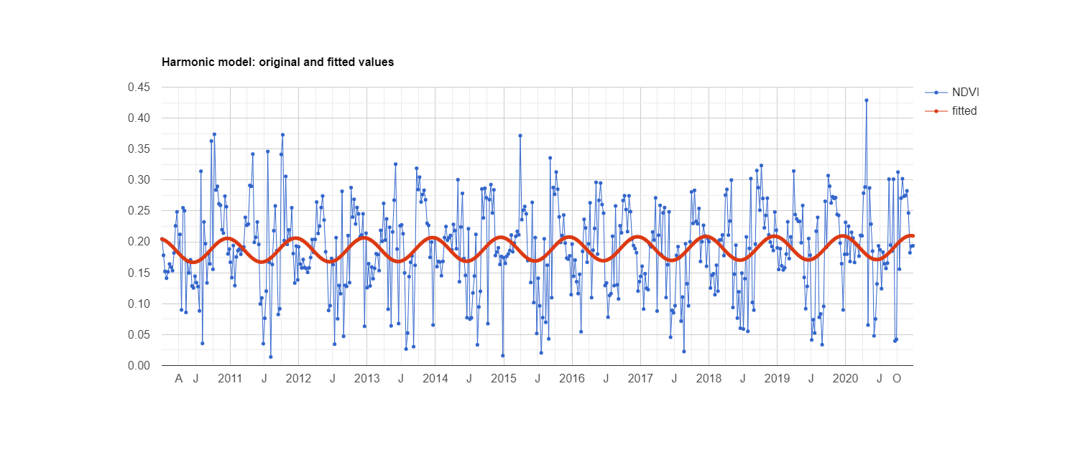

Fig: Harmonic Model for BD

For Bangladesh: Maximum = 0.556, Minimum = 0.378 and mean = 0.466

• **Estimate the autocorrelation function. Select the most appropriate lag to be considered.  
(Add the maps of the autocorrelation values at the selected lag)**

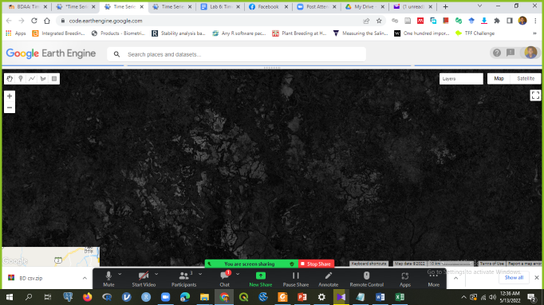

Autocorrelation map at lag value 9 for Castallia_la_mancha.

• Combine the different seasonal metrics to identify and map different crop rotations.

• Display a map with the result and some examples of time series of the different classes.

• Repeat the same step choosing an agricultural area in Bangladesh.

• Describe the different crop rotation systems found and the differences between study  
areas.

• Include the script(s) used in the assessment report.